EXPT NO:7 | OVER-PLOTTING REDUCTION TECHNIQUES
DATE: 09.02.2026

PRE-LAB QUESTIONS

Why is over-plotting common in big data visualization?
Over-plotting is common because big data contains thousands or millions of points, and many points fall in the same positions on a graph. This causes points to overlap and hide the actual distribution.

How does data density affect perception?
When data density is high, the plot looks like a dark clustered region. This makes it difficult to identify important patterns like clusters, trends, and outliers, reducing the readability of the visualization.

What trade-offs exist between detail and clarity?
  - Showing every data point gives high detail, but it creates clutter and reduces clarity.
  - Using aggregation/binning improves clarity, but it reduces the visibility of individual data points.
So the trade-off is between full detail vs clear understanding.

How do AI datasets increase visualization complexity?
AI datasets are usually large-scale, high-dimensional, and continuous, with many features and classes. This increases overlap in plots and makes it harder to visualize relationships clearly using normal plotting methods.

Why is over-plotting a serious analytical risk?
Over-plotting can hide important information such as:
  - minority patterns
  - outliers
  - true clusters
  - real correlations
This can lead to wrong conclusions and wrong decisions, especially in AI and business analytics.

OBJECTIVE : To apply techniques that reduce visual clutter in large-scale datasets.

SCENARIO A social media analytics company visualizes millions of user interactions to study engagement patterns.
IN-LAB TASKS (Using R Language) • Apply alpha blending • Implement jittering techniques • Use aggregation and binning

CODE:

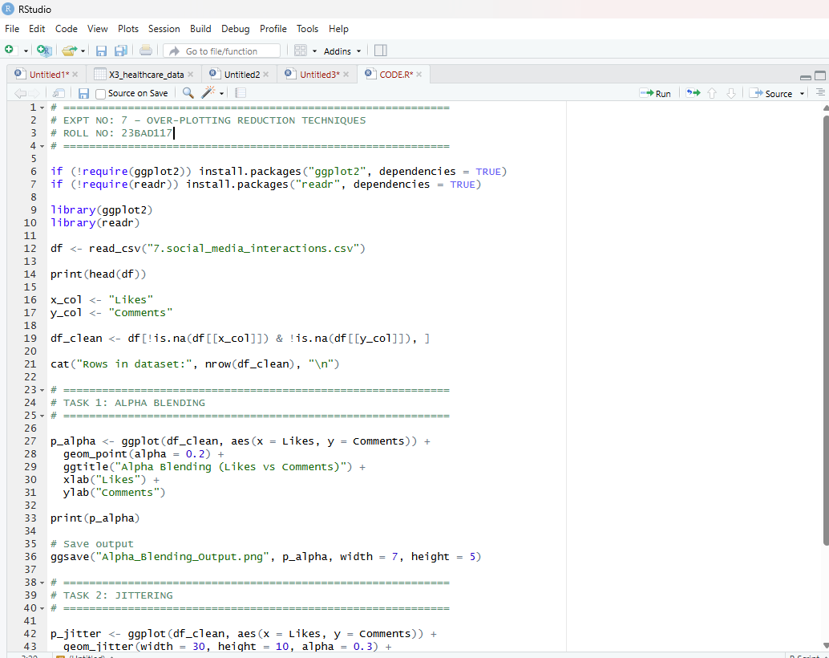

OUTPUT:
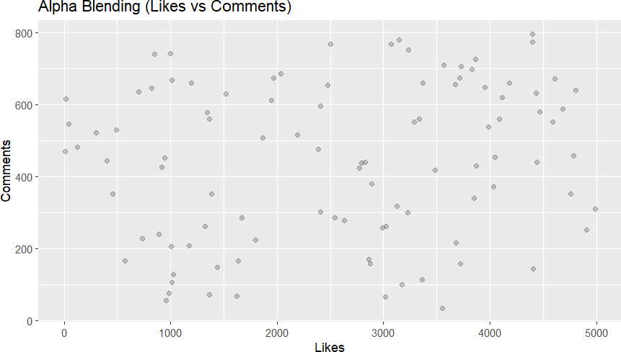
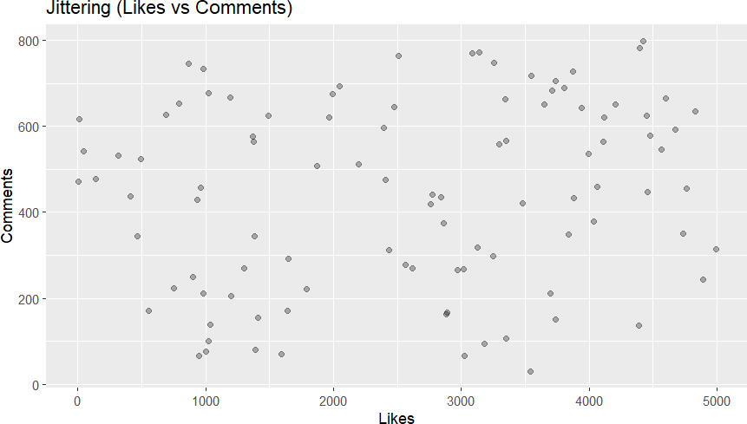

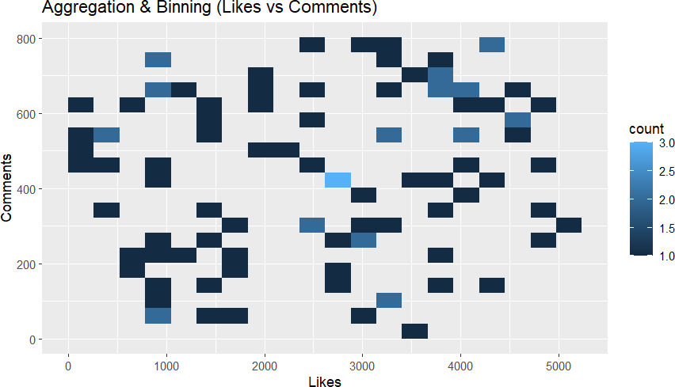

POST-LAB QUESTIONS

Which technique provided the best clarity and why?
Aggregation and binning (2D bin / hexbin) provided the best clarity because it groups overlapping points into bins and shows data density clearly. This makes patterns visible even when the dataset is large.

How does over-plotting distort analytical conclusions?
Over-plotting hides important patterns such as:
  - clusters
  - trends
  - outliers
  - rare behaviors
This can make the data look misleading and can cause incorrect conclusions about relationships between variables.

When should aggregation be preferred over raw plotting?
Aggregation should be preferred when:
  - the dataset is very large
  - points overlap heavily
  - the goal is to understand overall patterns (macro trends)
  - raw scatter plots become unreadable

How do these techniques support scalable AI analytics?
These techniques help scalable AI analytics by:
  - revealing real patterns in large datasets
  - improving readability and interpretability
  - supporting better feature analysis
  - helping detect bias, imbalance, and outliers
  - making large AI datasets easier to validate visually

Explain real-world consequences of ignoring over-plotting.
Ignoring over-plotting can cause:
  - wrong business decisions (marketing, targeting, engagement)
  - missing fraud/spam patterns
  - incorrect trend detection
  - poor AI model training insights
  - failure to identify rare but important user behaviors

LEARNING OUTCOME: Students master over-plotting reduction for big data visual analytics.

ASSESSMENT

Description | Max Marks | Marks Awarded
Pre Lab Exercise | 5
In Lab Exercise | 10
Post Lab Exercise | 5
Viva | 10
Total | 30
Faculty Signature

